Working in the Cloud

with ClearMedia Academy

ClearMedia vShield Edge deployment

**Disclaimer**:

By using the ClearMedia vCloud Director templates, you can greatly reduce the amount of time needed to deploy new VMs. These templates have been configured with the best practices in mind, to assure optimal stability and performance. Although use of the template is not compulsory, it is recommended!

This guide assumes you are building a new vApp based on Template version 1.4 and deploying the template from the “Catalog” tab with a single server setup. This document covers connecting the new vApp to the internet via the standard vShield Edge firewall and router.

In-Depth explanation and step-by-step procedures

* We assume that you have started with the “How-To 1 VMware Template 1.4” Document.
* Go to your vApp.
* Shutdown the vApp by pressing the red stop button under the tab vApp Diagram. Adding/deleting/changing networks requires that the vApp be in a shutdown state.

Afbeelding met schermafbeelding

Beschrijving is gegenereerd met zeer hoge betrouwbaarheid

* Go to the “Networking” tab
* Right click on the name “vAppNet-Template”, choose “Properties” and change the “Network name” under the tab “General”. Start with “vAppNet-<customername>“. Click OK.

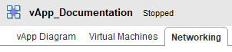

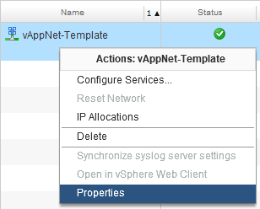 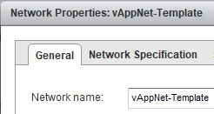

* Connect the vApp with the internet. Click on the dropdown menu under “Connection” and choose your “orgnet-direct-<partnername>”.
* Also check the tick box “Retain IP/Mac”.
* Click on “Apply”.

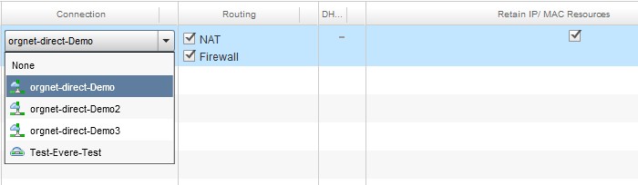

* Change the vShield Edge setting from “IP Translation” to “Port forwarding” on the “NAT” tab via “Configure Services” of the vAppnet.
* Ignore the warning about losing the firewall configuration. Click on OK.
* Add a port forwarding rule for RDP (TCP-UDP 3389). Do not turn off the option “Enable IP Masquerade”.

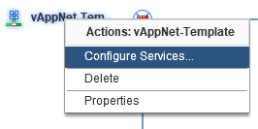

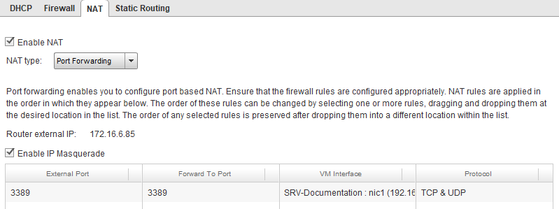

* On the firewall tab, add a Firewall rule for incoming RDP traffic. Allow both TCP and UDP. Also verify there is a Firewall rule for outgoing traffic and the “Default Action” is set to **Deny**.

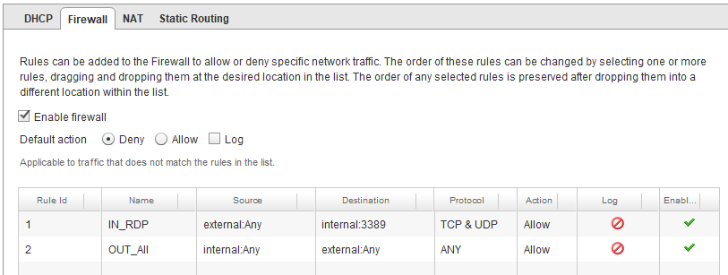

* Click on “Apply” again.
* Now start the entire vApp back up. Wait about 5 minutes for the vApp and VM to start.
* Find the NAT IP on the VSE by opening “Configure Services” again.



* Communicate the NAT IP for the vApp (172.16.x.x) to ClearMedia support so we can link it to a public WAN IP.
* Open the server again and Sync the iNSTALL folder with the ClearMedia GitHub site by right clicking on C:\iNSTALL\SyncGit.ps1 and clicking “Run with Powershell”.
* Use the ClearMedia provided BGInfo shortcut to verify that the public IP address is correct. Find it under C:\iNSTALL\BGInfo\PresetAndBgInfo – Shortcut or C:\ProgramData\Microsoft\Windows\Start Menu\Programs\StartUp\ PresetAndBgInfo – Shortcut
* Finished!